
are
St Aloysius’ College
Year 9 5.3 Term 3 Mathematics Assessment
Thursday 14th September 2017

NAME: ……………………………………………………
TEACHER: IMO GON MCR PLU

Time allowed: 40 minutes
Total Marks: 44

Instructions:

• Approved calculators may be used.
• All necessary working is to be shown for Part C.
• Marks may be deducted for careless or poorly arranged work.

PART A: Multiple Choice Questions: 10 marks

For questions 1 − 10, circle the correct answer, A, B, C or D on the answer sheet provided.

1. Simplify the following giving your answer in exact form 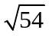

(A) 7.35 (B) 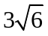 (C) 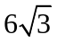 (D) 10.39

2. Write in gradient-intercept form 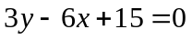

(A) 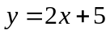 (B) 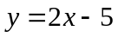 (C) 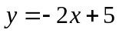 (D) 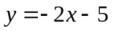

3. Write the following using positive indices 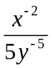

(A) 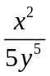 (B) 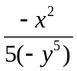 (C) 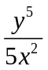 (D) 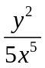

4. Calculate the IQR for the set of Quiz scores 2, 7, 11, 20, 8, 8, 10, 18, 19, 14

(A) 8 (B) 10 (C) 18 (D) 10.5

5. Factorise the following quadratic expression 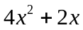

(A) 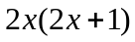 (B) 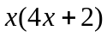 (C) 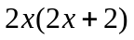 (D) 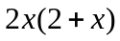

6. Expand 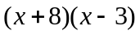

(A) 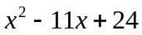 (B) 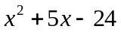 (C) 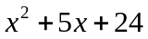 (D) 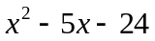

7. Simplify 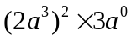

(A) 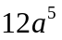 (B) 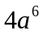 (C) 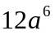 (D) 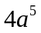

8. From the Venn Diagram, calculate P(A and B)
A
B

7
4
6

3

(A) (B) 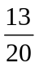 (C) 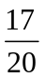 (D) 

9. Write 2 998 765 in scientific notation to 3 significant figures.

(A) 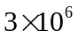 (B) 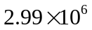 (C) 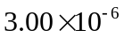 (D) 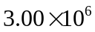

10. A standard 6-sided dice is rolled. Calculate P(Prime Number).

(A)  (B)  (C) (D)

End of Part A
NAME: ……………………………………………………
TEACHER: IMO GON MCR PLU
PART B:

Short Answer Questions: 10 questions. All questions are worth one mark. 10 marks

1. Factorise 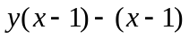

2. Simplify 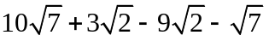

3. Calculate the midpoint of the interval joining points (1, –1) and (–3, 7).

4. A coin is flipped 80 times and a head appeared 25 times. Based on these results, how many heads would you expect if the coin was flipped another 1200 times.

5. What is the equation of the following line
6

O
 2

6. Factorise 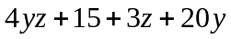

7. Factorise 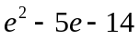

8. Write without using fractional indices 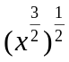

9. Factorise 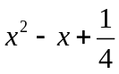

10. ABCD is a parallelogram. Find the coordinates of D.
y

C (4, 6)

D

x
0
B(–4, –1)
A (0, –3)

End of Part B

PART C:
NAME: ……………………………………………………
TEACHER: IMO GON MCR PLU

Extended Response Questions:

All necessary working is to be shown for Part C. 24 marks
Marks indicated for each question.

1. a) Sketch the line 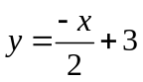 2
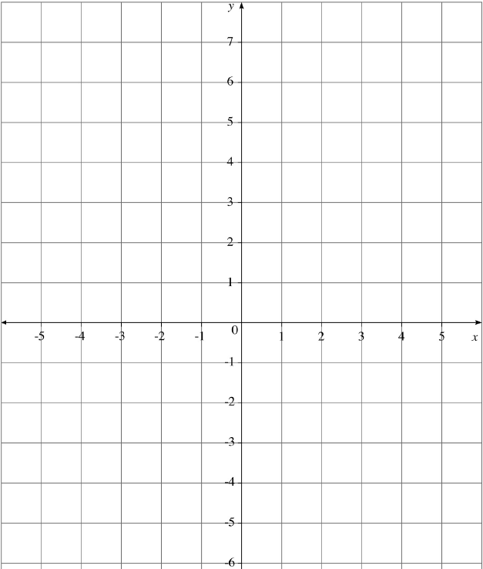

b) Find the equation of the line parallel to and through the point (-2, -1) 2

2. Simplify:
a) 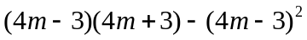 3

b) 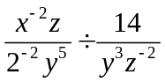 3

3. Factorise 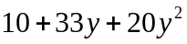 2

4. A medical study shows that two out of every three teenagers are immune to the chickenpox.
Two teenagers are chosen at random.
a) Draw a tree diagram representing all outcomes. 2

b) Find the probability that both teenagers chosen are immune. 1

c) Find the probability of choosing at least one teenager that is not immune. 1

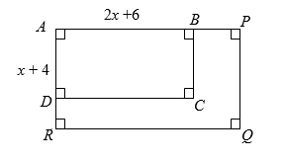
5. Mr O’Neill’s backyard is being renovated. His current back deck ABCD is (x + 4) cm wide and
(2x + 6) cm long. He has decided to increase both the length and width by 50%, giving APQR.

- Find the area of APQR in terms of x. 3

- Show that the difference between the areas of the two rectangles is 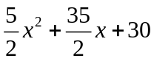 3

- If the original decks area was 40 m², by trial and error or otherwise, find how much 2
extra area has been added from the renovation.

End of Assessment

